**COUNTER 64 BIT**

Catalog

1. OVERVIEW 1

1.1 Introduction: 1

1.2 fuction: 2

1.3 feature: 2

2.BLOCK DIAGRAM 2

3.I/O LIST 2

4. FUNCTION DESCRIPTION 3

4.1 APB Slave Block 3

4.1.1 APB slave Block 3

4.1.2 Detail logic diagram 3

4.1.3. Description 3

4.1.4. Waveform 4

4.2 Register Block 5

4.2.1 Block register 5

4.2.2 Detail logic diagram 6

4.2.3 Description 7

4.2.4 Waveform 7

4.3 Counter control Block 8

4.3.1 Block counter control 8

4.3.2 Detail logic diagram 8

4.3.3 Description 9

4.3.4 Waveform 9

4.4.1 Counter 64 bit Block 9

4.4.1 Counter 64 bit block 9

4.4.2 Detail logic diagram 10

4.4.3 Description 10

4.4.4 Waveform 10

4.5 INTERRUPT BLOCK 11

4.5.1 Interrupt block 11

4.5.2 Detail logic diagram 11

4.5.3 Description 11

4.5.4 Waveform 11

5. REGISTER DESCRIPTION 11

Detail register : 12

* TCR : 12

* TDR0 : 12

* TDR1 : 13

* TCMP0 : 13

* TCMP1 : 13

* TIER : 14

* TISR : 14

* THCSR : 15

1. **OVERVIEW**
   1. **Introduction:**

▪ Timer is an essential module for every chip.

▪ This is used to generate accurate timing interval or controlling the timing of various operations within the circuit. Timer can be used in various application: pulse generation, delay generation, event generation, PWM generation, Interrupt generation ….

▪ In this project, a timer module is customized from CLINT module of industrial RISC-V architecture. It is used to generate interrupt based on user settings.

▪ The spec of CLINT can be referred at:

<https://chromitem-soc.readthedocs.io/en/latest/clint.html>

**1.2 fuction:**

▪ This is timer IP can be used counter(64bit).

▪ [Advanced level] Halted mode.

▪ Timer interrupt.

▪ Counting mode.

▪ APB slave/register.

**1.3 feature:**

▪ count up(64-bit).

▪ Address space: 4KB (0x4000_1000 – 0x4000_1FFF)

▪ Register set is configured via APB bus (IP is APB slave).

▪ Support timer interrupt (can be enabled or disabled).

▪ System clock frequency is 200 MHz. Timer uses active low async reset.

▪ Counter can be counted based on system clock or divided up to 256.

**▪ Standard level:**

o Only support APB 32-bit transfer with no wait states and no error handling

**▪ Advanced level:**

o Support wait state (1 cycle is enough) and error handling

o Support byte access

o Support halt (stop) in debug mode

**2.BLOCK DIAGRAM**

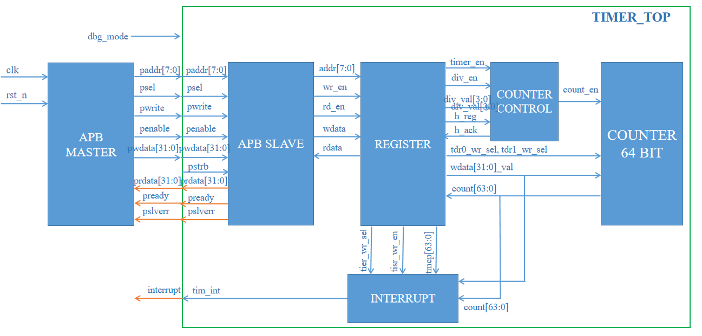

Figure 1: Block Diagram

**3.I/O LIST**

|  |  |  |  |
| --- | --- | --- | --- |
| sys_clk | 1 | input | Clock. The rising edge of PCLK times all transfers on the APB |
| sys_rst_n | 1 | input | Reset. The APB reset signal is active LOW. This signal is normally connected directly to the system bus reset signal. |
| tim_psel | 1 | input | Select. Active high select signal. The APB bridge unit generates this signal to each peripheral bus slave such as: TDR, TCR, TCMP0, TCMP1, TIER. TISR and THCSR |
| tim_pwrite | 1 | input |  |
| tim_penable | 1 | input | Enable. This signal indicates the second and subsequent cycles of an APB transfer. |
| tim_paddr | 8 | input | Address. This is the APB address bus. |
| tim_pwdata | 8 | input | Write data. |
| tim_prdata | 8 | output | Read data |
| tim_pstrb | 1 | input | Signal which bytes need to be written and which not. |
| tim_pready | 1 | output | Ready. The slave uses this signal to extend an APB transfer. |
| tim_pslverr | 1 | output | This signal indicates a transfer failure. |
| tim_int | 1 | output |  |
| dbg_mode | 1 | input | Debug mode |

1. **FUNCTION DESCRIPTION**

**4.1 APB Slave Block**

4.1.1 APB slave Block

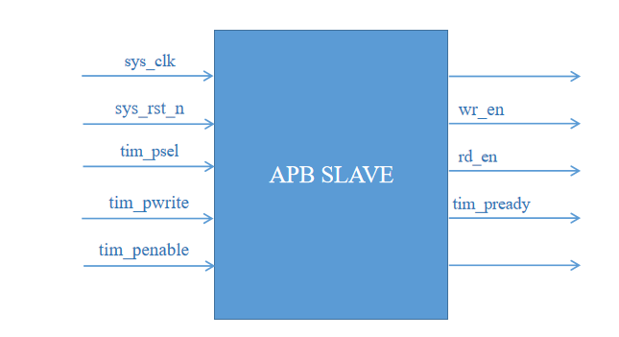

Figure 2 Register block

4.1.2 Detail logic diagram

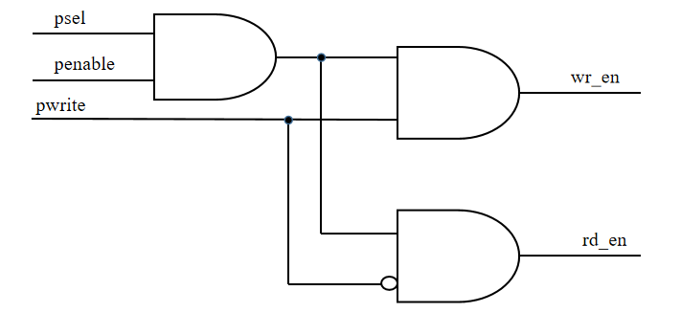

Figure 3 Logic diagram output APB Slave

4.1.3. Description

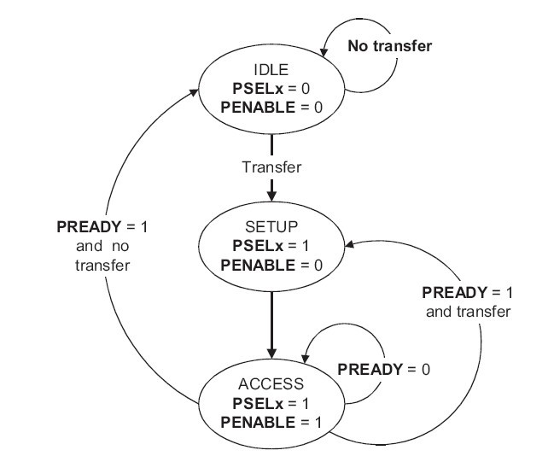

Figure 4 FSM_STATE

- The APB Slave performs read/write operations based on the coordination of the PSEL, PENABLE, and PWRITE signals:

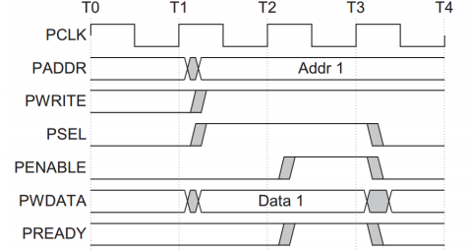

Figure 5 Write data

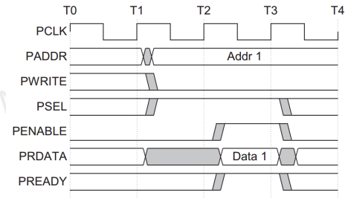

Figure 6 Read data

4.1.4. Waveform

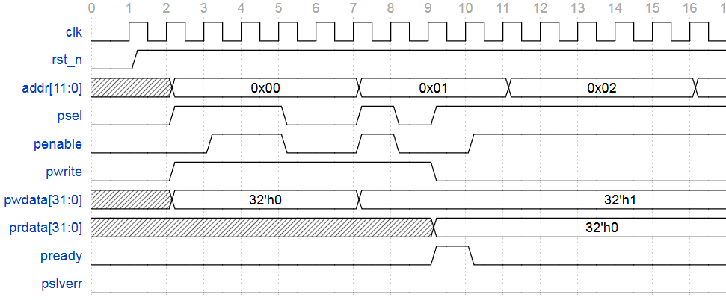

Figure 7 Waveform APB RW

**4.2 Register Block**

4.2.1 Block register

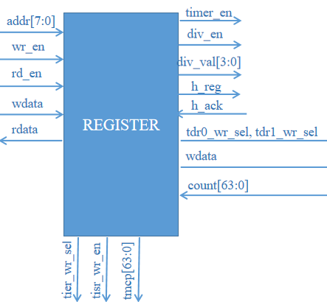

Figure 8 Block register

**Table : Port I/O Block Register**

|  |  |  |  |
| --- | --- | --- | --- |
| addr[11:0] | RW | input | address bus |
| wr_en | RW | input | 1: module access for writing  0: module access for reading |
| rd_en | RW | input | 1: module access for reading  0: module access for writing |
| wdata[31:0] | RW | input | register write data |
| rdata[31:0] | RO | output | Clock input |
| timer_en | RW | output | 1: start counting  0: stop counting |
| div_en | RW | output | External clock or pulse input |
| div_val[3:0] | RW | output |  |
| tdr0_wr_sel | RW | output | Select signal used to write to timer tdr0 |
| tdr1_wr_sel | RW | output | Select signal used to write to timer tdr1 |
| wdata_en[31:0] | RW | output | register write data |
| count[63:0] | RW | input |  |
| tcmp[63:0] | RW | output | Timer compare |
| tier_wr_sel | RW | output | Select signal used to write to timer tier |
| tier_wr_sel | RW | output | Select signal used to write to timer tisr |
| h_reg | RW | output |  |
| h_ack | RO | input |  |

4.2.2 Detail logic diagram

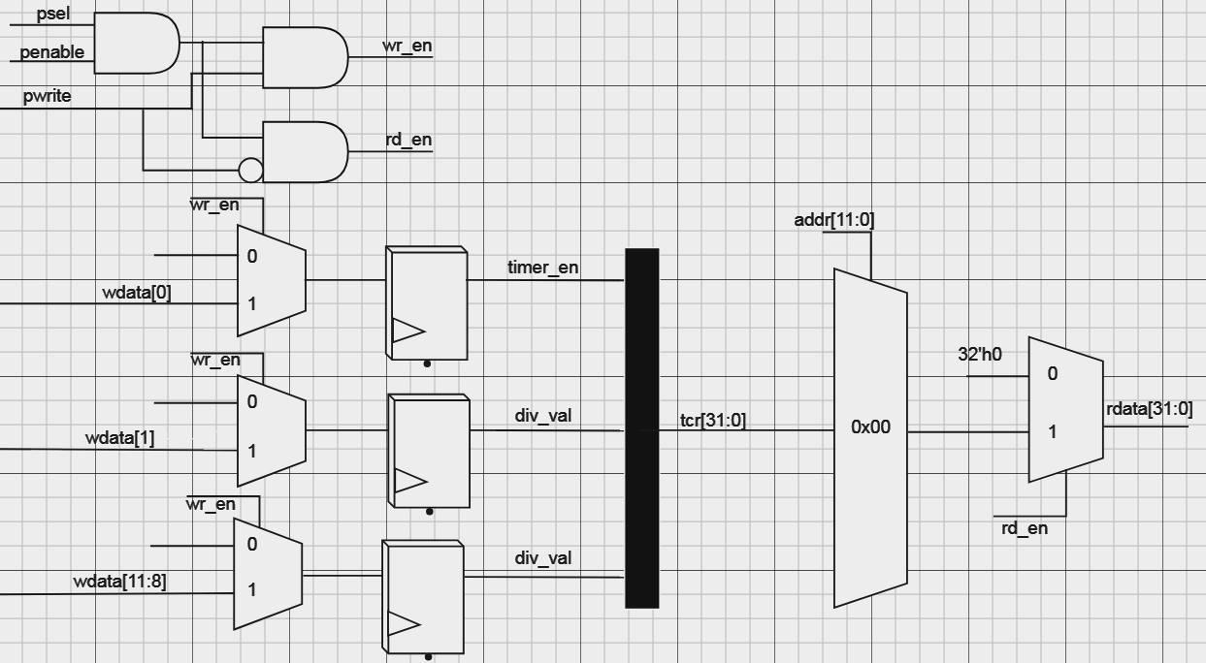

Figure 9 TCR[31:0] Register

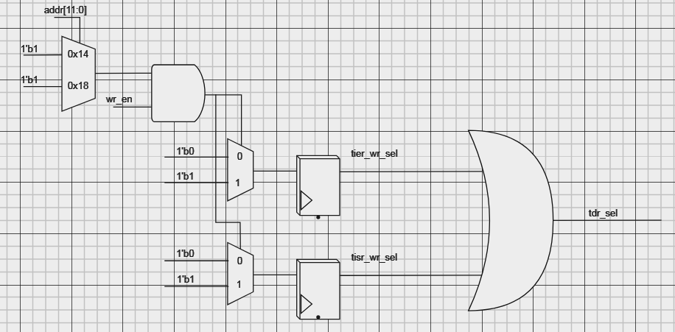

Figure 10 TDR0, TDR1 register

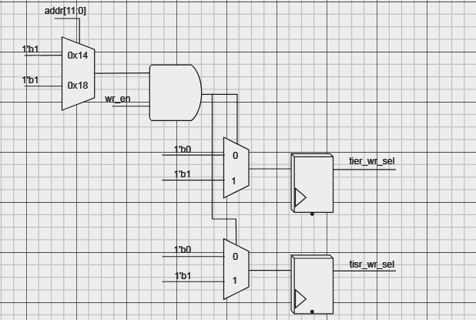

Figure 11 TIER, TISR_WR_SEL

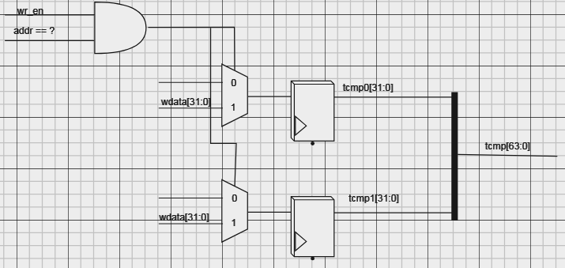

Figure 12 TCMP Register

4.2.3 Description

- TCR timer is the register used to control the counting operation of the counter:

timer_en[0] = 1 starts counting.

timer_en[0] = 0 stops counting.

div_en = 1 counts according to the external clock pulse.

div_val[3:0] pulse divider.

**-** TDR is data timer(tdr={tdr1, tdr0})

**-**

4.2.4 Waveform

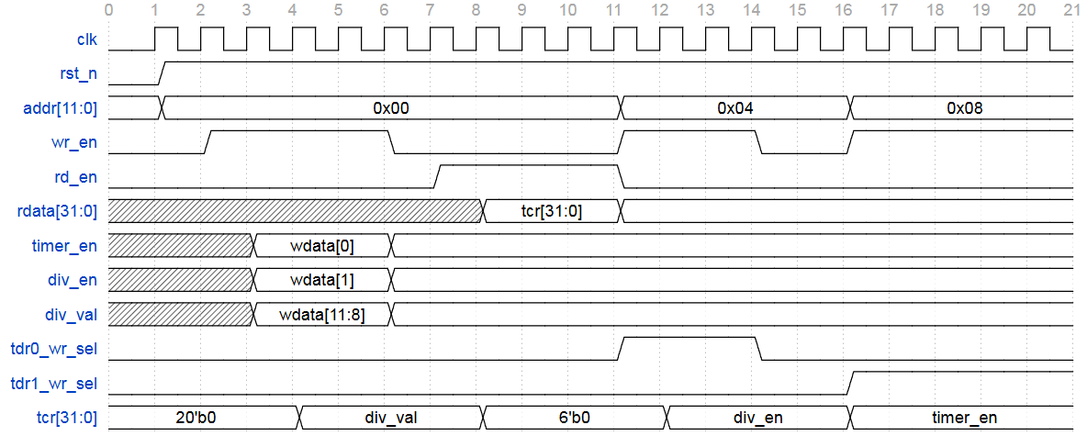

Figure 13 Waveform RW TCR register

**4.3 Counter control Block**

4.3.1 Block counter control

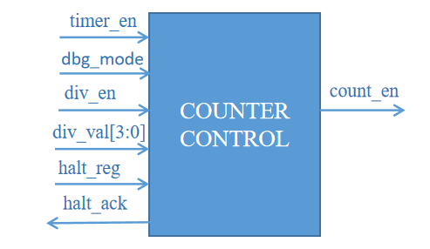

Figure 14 Counter control Block

4.3.2 Detail logic diagram

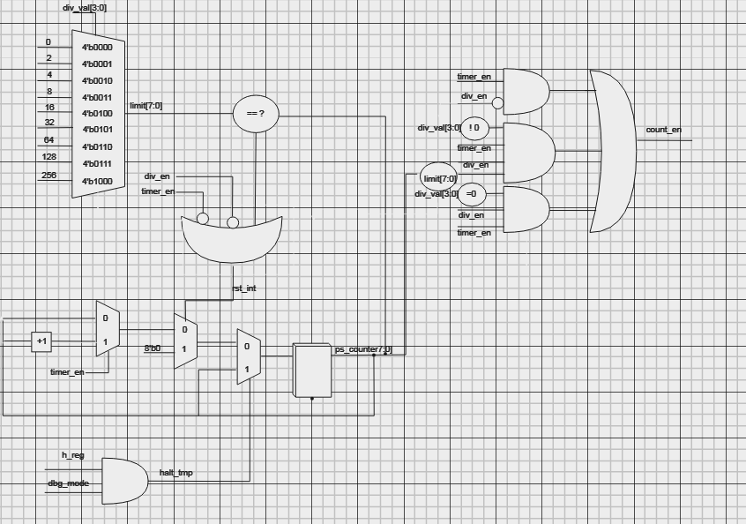

Figure 15 Logic diagram Counter Control Block

4.3.3 Description

**-** The function block has the function of selecting the counting mode for the Counter 64 bit block.

- Timer_en =1 Counter can be counted based on system clock.

- div_en =1 divided up to 256(div_val[3:0]).

- halt_reg and dbg_mode when high(1) will immediately stop the running counter mode

4.3.4 Waveform

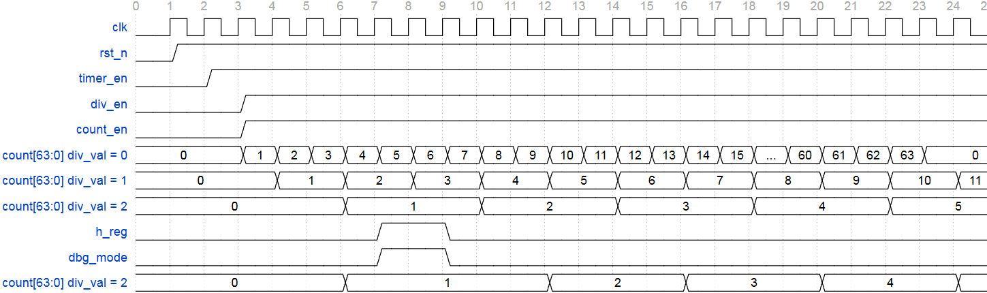

Figure 16 Counting mode

**4.4.1 Counter 64 bit Block**

4.4.1 Counter 64 bit block

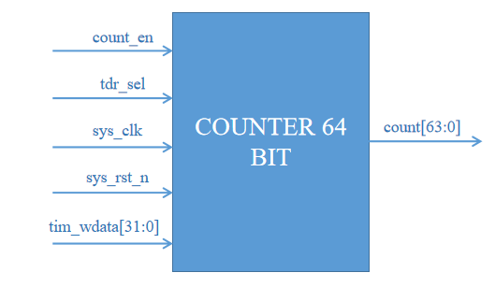

Figure 17 Counter 64 Bit Block

4.4.2 Detail logic diagram

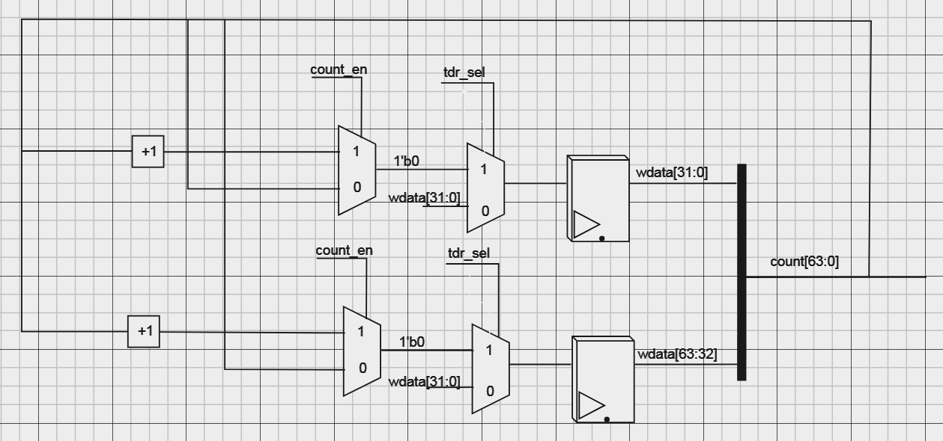

Figure 17 Logic diagram counter Block

4.4.3 Description

- wr_en & (addr == 0x00) is enabled(1) then:

+ timer_en <= wdata[0]

+ div_en <= wdata[1].

+ div_val <= wdata[11:8].

4.4.4 Waveform



Figure 18 Waveform Counter

**4.5 INTERRUPT BLOCK**

4.5.1 Interrupt block

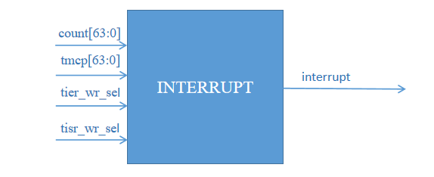

Figure 19 Interrupt Block

4.5.2 Detail logic diagram

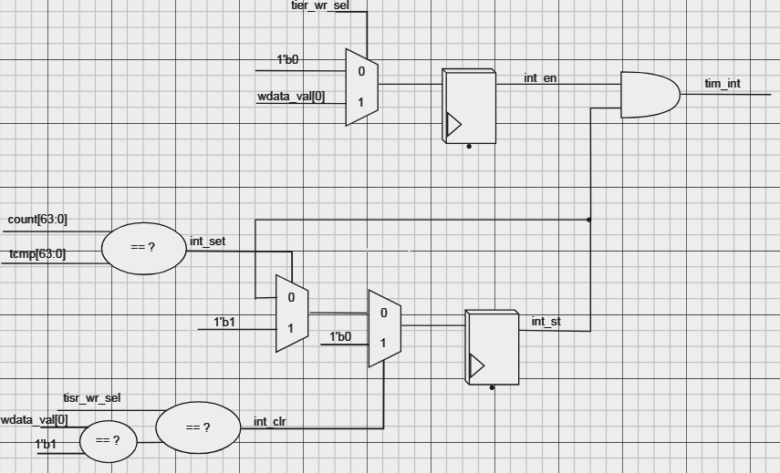

Figure 20 Logic diagram Interrupt Block

4.5.3 Description

- int_set is enabled when the count value is equal to the compare value (tmcp).

- int_clr is enabled (1) when the tisr_wr_sel signal is active and wdata[0]_val is equal to , used to reset the int_st signal to 0.

- tim_int is asserted when int_en and int_set both assert.

- Once asserted, the timer interrupt (tim_int) remains unchange until it is cleared by writing 1 to TISR.int_st bit or the interrupt is disabled.

4.5.4 Waveform

1. **REGISTER DESCRIPTION**

Base Address :

|  |  |  |
| --- | --- | --- |
| **Offset** | **Abbreviation** | **Resister name** |
| 0x00 | TCR | Timer Control Register |
| 0x04 | TDR0 | Timer Data Register 0 |
| 0x08 | TDR1 | Timer Data Register 1 |
| 0x0C | TCMP0 | Timer Compare Register 0 |
| 0x10 | TCMP1 | Timer Compare Register 1 |
| 0x14 | TIER | Timer Interrupt Enable Register |
| 0x18 | TISR | Timer Interrupt Status Register |
| 0x1C | THCSR | Timer Halt Control Status Register |
| Others | Reserved |  |

**Detail register :**

**\* TCR :**

▪ **address** : 0x00

▪ **size** : 32-bit

▪ **description** : Controls timer operation, including starting, stopping.

|  |  |  |  |  |
| --- | --- | --- | --- | --- |
| **bit** | **name** | **type** | **default value** | **description** |
| 11:8 | Div_val | RW | 4’b0001 | • 4’b0000: Counting speed is not divided  • 4’b0001: Counting speed is divided by 2 (default)  • 4’b0010: Counting speed is divided by 4  • 4’b0011: Counting speed is divided by 8  • 4’b0100: Counting speed is divided by 16  • 4’b0101: Counting speed is divided by 32  • 4’b0110: Counting speed is divided by 64  • 4’b0111: Counting speed is divided by 128  • 4’b1000: Counting speed is divided by 256 |
| 7:2 | Reserved | RO | 6’b0 | Reserved |
| 1 | div_en | RW | 1’b0 | Counter control mode enable.  • **0**: Disabled. Counter counts with normal speed based on system clock  • **1**: Enabled. The couting speed of counter is controlled based on div_val  Note: user must not change div_en while timer_en is High  (*): add hardware logic to ensure div_en is prohibited to change when timer_en is High. Access is error response in this case. |
| 0 | timer_en | RW | 1’b0 | • **0**: Disabled. Counter does not count.  • **1**: Enabled. Counter starts counting.  (*) timer_en changes from H->L will initialize the TDR0/1 to their initial value |

**\* TDR0 :**

▪ **address** : 0x04

▪ **size** : 32-bit

▪ **description** : Stores the current count value or initial value for Timer 0.

|  |  |  |  |  |
| --- | --- | --- | --- | --- |
| **bit** | **name** | **type** | **default value** | **description** |
| 31:0 | TDR0 | RW | 32’h0000_0000 | • Lower 32-bit of 64-bit counter.  H -> L : clear |

-----------------------------------------------------------------------------------------------

**\* TDR1 :**

▪ a**ddress** : 0x08

▪ **size** : 32-bit

▪ **description** : Stores the current count value or initial value for Timer 1.

|  |  |  |  |  |
| --- | --- | --- | --- | --- |
| **bit** | **name** | **type** | **default value** | **description** |
| 31:0 | TDR1 | RW | 32’h0000_0000 | • Upper 32-bit of 64-bit counter.  H -> L : clear |

-----------------------------------------------------------------------------------------------

**\* TCMP0 :**

▪ **address** : 0xC

▪ **size** : 32-bit

▪ **description** : Set the compare value for Timer 0, trigger an interrupt when this value is reached

|  |  |  |  |  |
| --- | --- | --- | --- | --- |
| **bit** | **name** | **type** | **default value** | **description** |
| 31:0 | TCMP0 | RW | 32’hFFFF_FFFF | • The TCMP0 register contains the low 32 bits of the 64 bits of the compare value.  • The interrupt will be triggered when the count value equals the lower 32bit value of this timer.  **EX:** Compare Value (64-bit) = 0x1234_5678_9ABC_DEF0  TCMP0: 0x9ABC_DEF0  TCMP1: 0x1234_5678 |

**\* TCMP1 :**

▪ **address** : 0x10

▪ **size** : 32-bit

▪ **description** : Set the compare value for Timer 1, trigger an interrupt when this value is reached

|  |  |  |  |  |
| --- | --- | --- | --- | --- |
| **bit** | **name** | **type** | **default value** | **description** |
| 31:0 | TCMP1 | RW | 32’hFFFF_FFFF | • The TCMP0 register contains the upper 32 bits of the 64 bits of the compare value.  • The interrupt will be triggered when the count value equals the upper 32bit value of this timer.  **EX:** Compare Value (64-bit) = 0x1234_5678_9ABC_DEF0  TCMP0: 0x9ABC_DEF0  TCMP1: 0x1234_5678 |

**\* TIER :**

▪ **address** : 0x14

▪ **size** : 32-bit

▪ **description** : Controls the interrupt or non-interrupt operation from the timer

|  |  |  |  |  |
| --- | --- | --- | --- | --- |
| **bit** | **name** | **type** | **default value** | **description** |
| 31:1 | Reserved | RO | 31’b0 | Reserved |
| 0 | int_en | R/W | 1’b0 | **0**: Timer interrupt is disabled.  **1**: Timer interrupt is enabled.  • When this bit is 0, no timer interrupt is output.  • When this bit is 1, timer interrupt can be output when reaching  trigger condition.  … |

**\* TISR :**

▪ **address** : 0x18

▪ **size** : 32-bit

▪ d**escription** : Indicates the status of the timer interrupt.

|  |  |  |  |  |
| --- | --- | --- | --- | --- |
| **bit** | **name** | **type** | **default value** | **description** |
| 31:1 | Reserved | RO | 31’b0 | Reserved |
| 0 | int_st | R/W1C | 1’b0 | Timer interrupt trigger condition status bit (interrupt pending bit)  **0**: the interrupt trigger condition does not occur.  **1**: the interrupt trigger condition occurred.  Write 1 when this bit is 1 to clear it  Write 0 when this bit is 1 has no effect  Write to this bit when it is 0 has no effect.  **Note:** When interrupt trigger condition occurred (counter reached  compare value), counter continues to count normally |

**\* THCSR :**

▪ **address** : 0x1C

▪ **size** : 32-bit

▪ d**escription** :

|  |  |  |  |  |
| --- | --- | --- | --- | --- |
| **bit** | **name** | **type** | **default value** | **description** |
| 31:2 | reserved | RO | 30’h0 | reserved |
| 1 | halt_ack | RO | 1’b0 |  |
| 0 | halt_reg | RW | 1’b0 |  |